Mech 436
Control Systems
Floating ball system Project


American University of Beirut
Department Of Mechanical Engineering
Professor Dany Abou Jaoude

Submitted By Roudy Hassan, Jawad El Dika , Elias Hanna

Table of contents
1 .Introduction : 4
1.1 Definition: 4
2.Literature Review: 5
2.1.Free Body Diagram: 5
2.2.Defining Our Variables : 6
2.3.Newton’s 2nd Law : 6
3.Hardware Implementation: 9
3.1.Components Used : 9
3.2.Prototype : 11
4.System Identification : 12
4.1.Experimental Data 12
4.2.MATLAB and controllers implementation: 14
4.3. Pd controller: 16
4.3.1Fine Tuning of the Pd controller: 19
4.4.PID controller : 20
4.4.1PID controller , Fine Tuning : 23
5. Hardware Application : 25
6.Appendix 26

Table of Figures:
Figure 1: 12V PWM FAN 9
Figure 2: PHI = 4cm Ping pong ball 9
Figure 3: PHI = 4.4 cm Plexi glass pipe 9
Figure 4 : 12 v Power supply 9
Figure 5: Arduino Uno Micro controller 10
Figure 6: Bread Board 10
Figure 7: Electrical wires 10
Figure 8: Ultra sonic sensor 11
Figure 9: Actual Prototype 11
Figure 10:Step Response of the uncompensated system 15
Figure 11: Root locus of the uncompensated system 15
Figure 12: Root locus for the compensated system using PD but untuned 17
Figure 13: Step response for the compensated system using PD but untuned 18
Figure 14: Step of the compensated and Tuned system using PD 20
Figure 15: Root locus of the compensated system but untuned using PID 21
Figure 16: minimized view for the sgrid function 22
Figure 17:Step of the compensated and tuned system using PID 24

1. Introduction:

1.1 Definition:

A classic control problem that is frequently used in research to illustrate feedback control concepts is the ball and pipe system. A lightweight ball typically rests inside a vertical tube or pipe, and the ball's vertical position is controlled and suspended by airflow from a fan.
A 4-pin PWM-controlled fan is used in typical configuration to control airflow. A microcontroller such as an Arduino uno gets feedback on the ball's position from infrared or ultrasonic sensors. By dynamically modifying the fan speed in response to the discrepancy between the setpoint and the measured location, the system aims to keep the ball in the pipe at the required height.
The setpoint, or intended height, and the ball's measured height are compared for the control logic to function. The fan speed is dynamically adjusted using errors, which is the difference between these two numbers. The controller raises the fan speed to push the ball higher if it starts to fall below the setpoint and lowers it if it starts to climb too high. The system aims to keep the ball suspended at the desired height inside the pipe by continuously adjusting the airflow based on this error. This illustrates important ideas like steady-state error minimization, response time, system stability, and proportional, integral, and derivative (PID) control.
This experimental platform is a popular option for both academic and real-world learning situations because it offers practical experience with sensor integration, real-time control algorithms, and system modeling in addition to providing a physical presentation of feedback control theory.

2.Literature Review:

2.1.Free Body Diagram:
Drag Force + Buoyant Force
Ball
Gravitational Force

2.2. Defining Our Variables:

The buoyant force, the aerodynamic drag force, and the gravitational force (weight) are the main forces influencing the system. As a result, each of these forces and the variables that go along with them must first be defined.

Below are the Variables needed:

-g=gravitational constant = 9.81 N/ (kg.m^2)
-m=mass of the ball = 2.7 *10^-3
-ρ= density of the air = 1.225 kg /m^3
-Cd= drag coefficient = 0.47
-A=cross section of the ball = 5.0265 m^2
-V=velocity inside of the pipe
-z=position of the ball
-$V_{b}$ =ball’s volume = 2.68 *10^-4 m^3

2.3. Newton’s 2nd Law:

Applying Newton’s 2nd law:
- F g = m ・ g (gravitational Force)
- Fb = ρ ・g ・ $V_{b}$ (buoyant Force)
- F d =$\frac{1}{2}$*( ρ ・ Cd ・ A ・ (v f − z˙)2) (Drag force)

We have the following:
$$m*\ddot{z}=F_{d}+F_{b}-F_{g}$$

by isolating the acceleration of the ball, we obtain the following:
$$-\ddot{z}=\frac{1}{2m}*\left(C_{d}*ρ*A\left(V-\dot{z}\right)\right)*2+\frac{1}{m}*\left(ρ*g*V-g\right) \left[1\right]$$

In our system the position of interest is the equilibrium position (steady state), meaning that the ball is no longer moving, hence we can set. ( $\ddot{z}=\dot{z}=0)$

Hence, we will be able to represent our gravitational force in a different way:
$-g=\frac{ρ*C_{d}*A*V_{new}^{2}}{2*\left(m-ρ*V_{b}\right)} [2]$
Where $V_{new}=4.009 \frac{m}{s}$is the velocity of air at equilibrium.
Combining the equation [2] with the equation [1] we obtain the following:
$-\ddot{z}=g*\left(\frac{m-ρ*V_{b}}{m}\right)*\left({\left(v_{f}-\frac{\dot{z}}{V_{new}}\right)}^{2}\right)-1)$

The presence of the ^2 Term causes Non-linearities for the system , Hence we can linearize the system by some approximation about a certain point.
Let $x=\frac{V-\dot{z}}{V_{new}}$
$f\left(x\right)≈f\left(x_{0}\right)+f’\left(x_{0}\right)*\left(x-x_{0}\right)$(Taylor series Expansion)
The linearised version is: $-\ddot{z}=\left(2*\frac{g}{V_{new}}\right)*\left(\frac{m-ρ*V_{b}}{m}\right)*\left(V-\dot{z}-V_{new}\right)$
Applying the Laplace transform and considering that the system input is the fan’s speed while the output is the ball’s vertical position, we recognize that the system dynamics involve acceleration. Therefore, the resulting transfer function should take the following general form:
$$G\left(s\right)=\frac{Y\left(s\right)}{V\left(s\right)}=\frac{K_{g}}{s\left(s+a\right)}$$
Where $a=2*g*\frac{m-ρ*V_{b}}{V_{new}*m}=4.2988$

However, this Transfer function is Not complete we need to add the constant ‘K’ of Velocity / voltage:
So by taking several voltages with our simulations we were able to determine our Constant ‘K’ :
it is approximately 1.35 $\frac{m}{S.V}$:
‘This process is Done by taking several points, for our used Fan and measuring The rpm for each Voltage, hence we can notice a linear relation That is being built’
Hence our Transfer function can be written as such:

- G new = $\frac{5.79}{ s*(s+4.2899)}$

As an additional Information we have determined V-equivalent (i.e.) the minimum voltage that is actually needed for the ball to start running , at 29.95 PWM by proportionality:

- V-equivalent = $\frac{29 .95}{255}*12.5$ = 1.468 Volts.

3.Hardware Implementation:

3.1. Components Used :
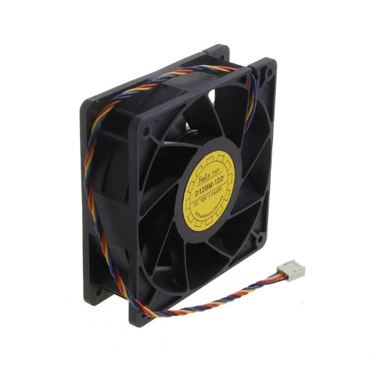
Figure 1: 12V PWM FAN

Figure 2: PHI = 4cm Ping pong ball

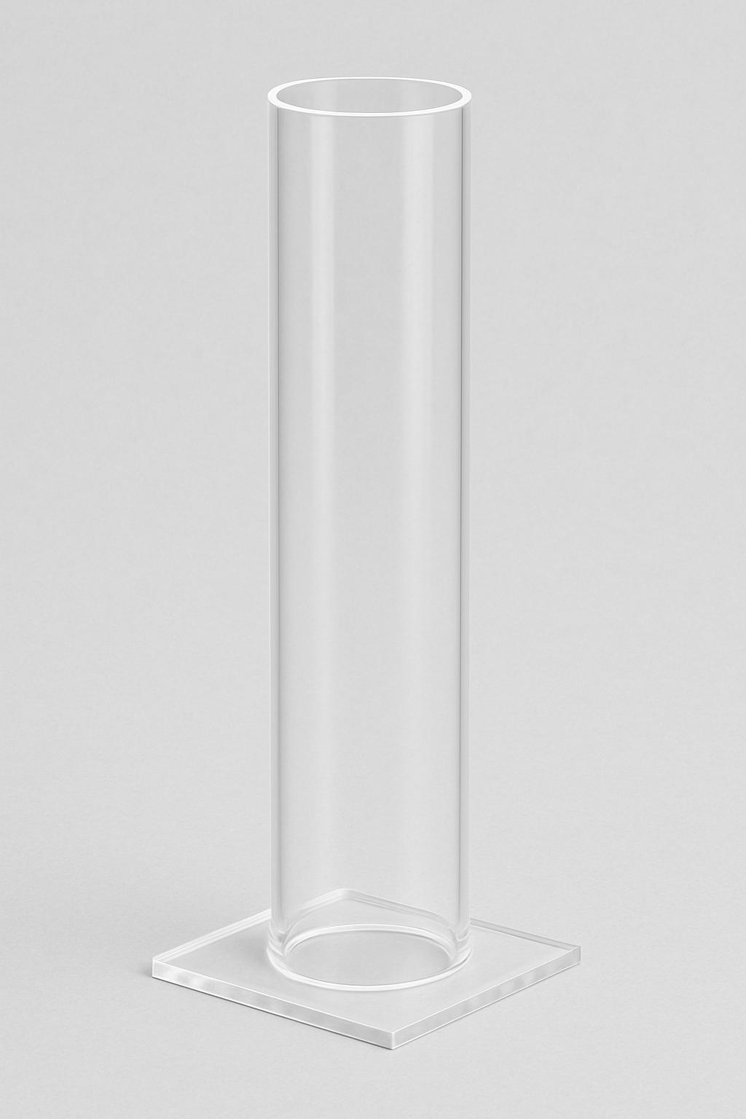
Figure 3: PHI = 4.4 cm Plexi glass pipe
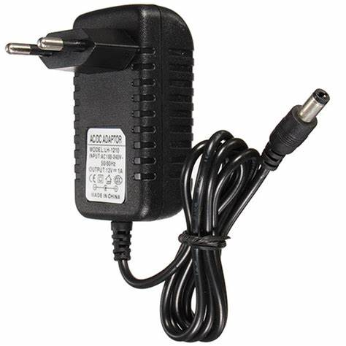
Figure 4 : 12 v Power supply

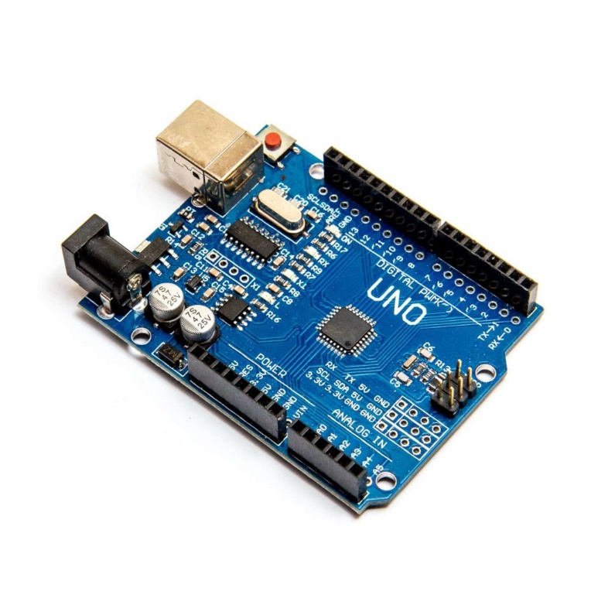
Figure 5: Arduino Uno Micro controller

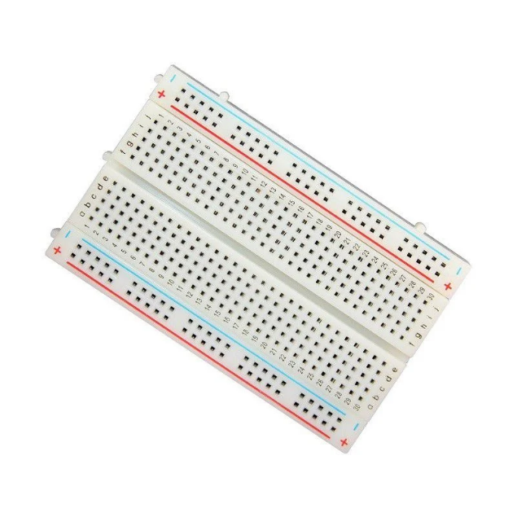
Figure 6: Bread Board

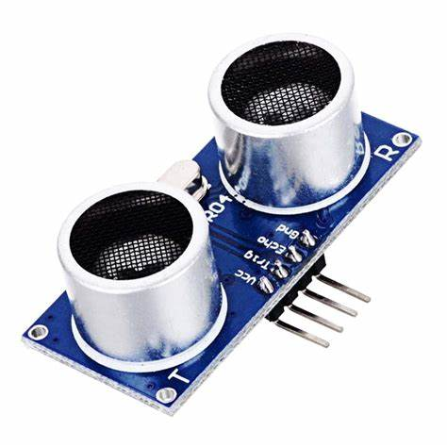
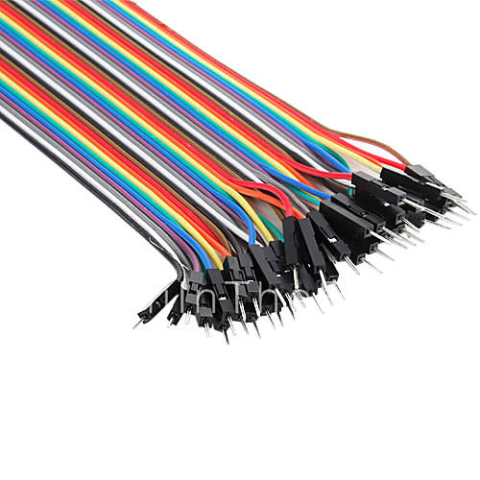
Figure 7: Electrical wires

Figure 8: Ultra sonic sensor

3.2. Prototype:
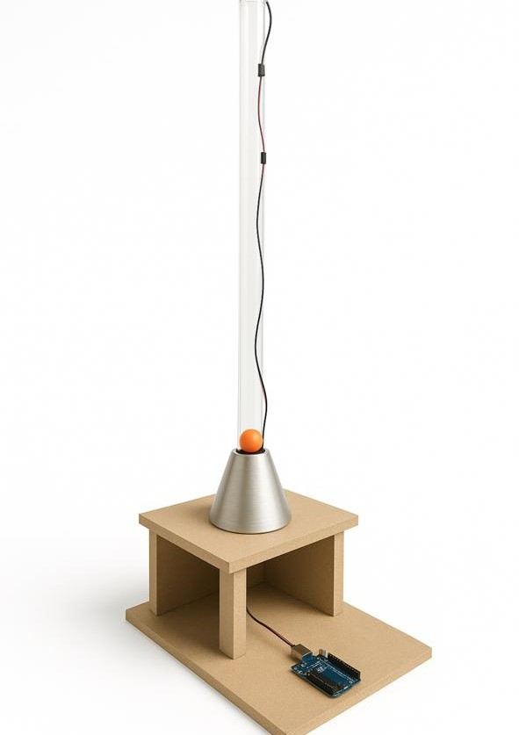
Figure 9: Actual Prototype

4.System Identification:

4.1. Experimental Data

In order to identify the closed loop and open loop transfer functions for our system we are required to determine some data experimentally, below there is a Table shown where for every Value of Kp , zeta and Wn were found

Given the following:
-Tp = $\frac{pie}{rad\left(1-zeta^{2}\right)*Wn}$

-$M_{p}$= $\frac{Z\left(peak\right)-Z\left(final\right)}{Z\left(final\right)}$ But we also know that $M_{p}$ = $e^{- \frac{π*zeta}{rad(1-zeta^{2})}}$
Hence by finding each point’s overshoot and Peak time, we can determine zeta and Wn for each measurement:
Kp | Tp (Seconds) | Peak Value | %Overshoot
0.5 | 3.17 | 70-15=55 | 0.83
0.6 | 2.63 | 70-17=53 | 0.76
0.7 | 2.58 | 70-18.4=51.6 | 0.72
0.8 | 2.33 | 70-19.3=50.7 | 0.69
0.9 | 2.03 | 70-20.2=49.8 | 0.66

Zeta | Wn
0.059 | 0.992
0.087 | 1.199
0.103 | 1.224
0.117 | 1.357
0.131 | 1.567
Zeta avg=0.0992 | Wn avg=1.266

By taking the average of our measurements, we have found the average zeta and Wn hence we were able to determine the transfer functions of the open loop and closed loop system experimentally:

Closed loop transfer function: $\frac{Wn^{2}}{s^{2}+(2*zeta*Wn*)s+Wn^{2}}$
By replacing the Values with the experimental zeta and Wn:

- $\frac{{\left(1.266\right)}^{2}}{s^{2}+0.2235*s+{1.266}^{2}} =\frac{1.602}{( s^{2}+0.2235*s+1.602)}$

The open Loop Transfer function: $G\left(s\right)=\frac{kg}{s\left(s+a\right)}$
- In other words, set $\frac{1.602}{( s^{2}+0.2235*s+1.602)}$ = $\frac{G}{1+G}$

Our open loop Transfer function is $: G\left(s\right)=\frac{1.602}{ s^{2}+0.2235*s}$

4.2. MATLAB and controller’s implementation:

Firstly, we have found our desired point (i.e.) our desired zeta and Wn:
From the requirements, MP <=10 % and Ts <= 2.5 seconds.

Hence s-desired = -zeta*Wn +/- (Wn*rad(1-zeta^2)) j = -1.6 +/- 2.183 j

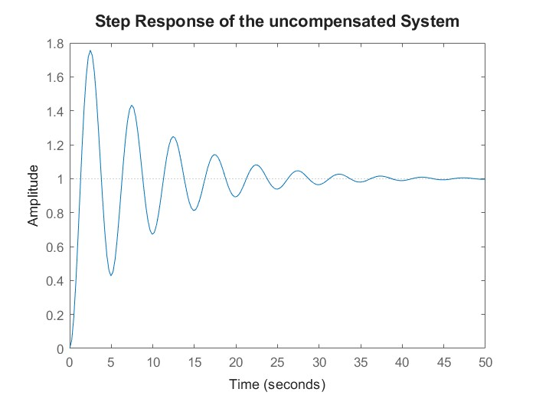
Now by implementing our open loop transfer function, we generated a step plot for the closed loop transfer function and the root locus for the open loop transfer function joined with the s-grid of zeta and Wn .

Figure 10:Step Response of the uncompensated system
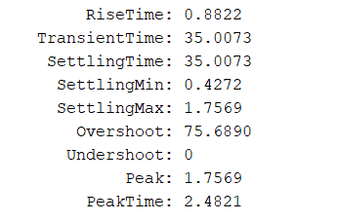

With the use of the built-in function stepinfo () It is clear that we are exceeding the requirements.
Since Mp = 75.6890 > 10 % and Ts = 35.0073 > 2.5 s.

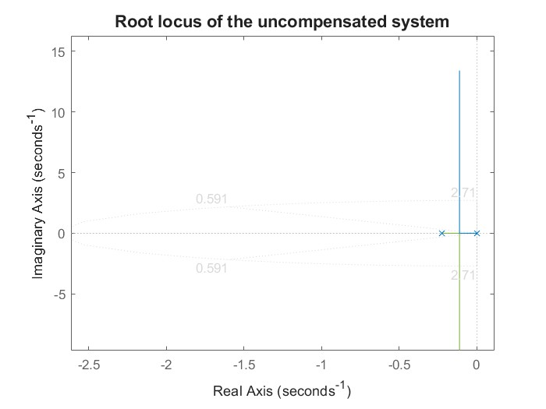
Figure 11: Root locus of the uncompensated system

The Root locus gives additional information, by applying the built-in function Sgrid (zeta, Wn). This function generates a line of a constant value of zeta and a constant value of Wn the point of intersection represents the s-desired, from the following figure our system does not meet the s-desired.

4.3. Pd controller:
From the data generated Previously, we have determined the need for a controller we started by implementing a PD controller which can help in improving its response (i.e.) Percentage Overshoot and the settling time.

As an intermediate step, we need to find the angle of deficiency to determine the dynamics of our PD controller.
Using this formula on MATLAB:

D =- pi.
for i=1: length(P)
D=D+atan2 (imag (Sp(1)-P(i)), real (Sp (1)-P(i)).
End

We Have determined D (. i.e.) angle of deficiency, hence we can now find our zero:
Z pd=-(imag (Sp (1))/tan(D)) +real (Sp (1)) = -2.4611.
With D = 68.47 deg; Zpd was found

Hence the transfer function for our controller is: Gc1(s) = $\frac{s+2.4611}{1}=s+2.4611$

The gain K is found from the magnitude condition, or we can apply the built-in function on MATLAB: [k poles] = rlocfind(G1c); K = 1.8567
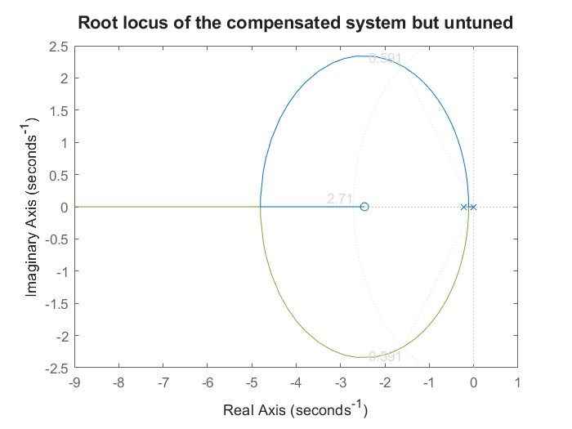

Figure 12: Root locus for the compensated system using PD but untuned

(The desired point is very close to the root locus , but is does not intersect on it .)

Now the transfer function is G (s) * Gc(s) * K = $\frac{1.602}{ s*(s+0.2235)}*\left(s+2.461\right)* 1.8567$

For further clarification, we apply Step and Stepinfo () For our new transfer function.
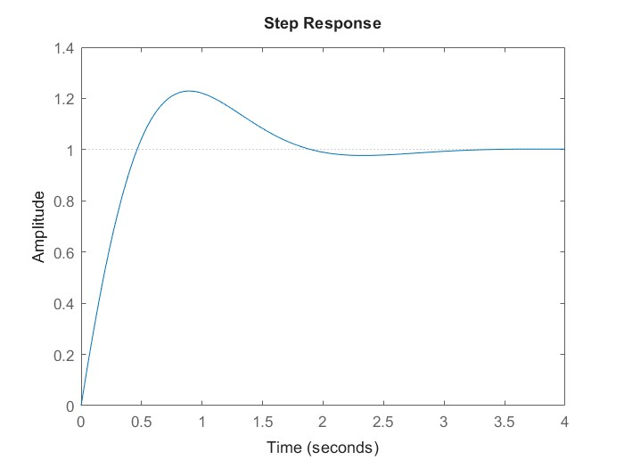
Figure 13: Step response for the compensated system using PD but untuned

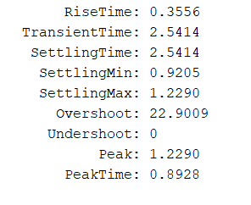

We can Observe that the response has Improved but it still does not meet our requirements Mp = 22.9009 > 10 and Ts = 2.5414 > 2.5 , Hence some fine tuning is required (.i.e.) we need to follow an iterative approach where we will modify KP and KD and for each value we will implement the built in function Stepinfo() in order to observe the response , below is a Table showing the values KP and KD and their resulting Mp and Ts .

4.3.1. Fine Tuning of the Pd controller:

Table showing the Fine tuning for our Pd controller:
Kp: | Kd: | Ts (seconds): | Mp (%):
4.569 | 1.8568 | 2.5414 | 22.9009
6.854 | 2.7852 | 1.4838 | 18.8576
11.4244 | 4.642 | 1.2117 | 14.1904
15.994 | 6.4988 | 1.0601 | 11.5031
20.5639 | 8.3556 | 0.9503 | 9.7243

As shown Above 5 iterations were needed, with a visual check on the system’s response to a Step Input to reach a satisfactory result at Kp = 20.5639 and KD = 8.3356.
Below are the final versions of the system’s response to a step input and the system’s criteria using the built-in function Stepinfo ().
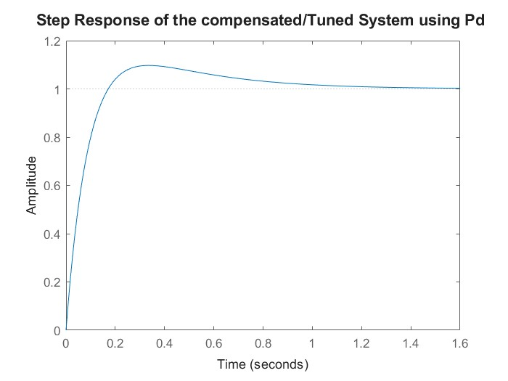
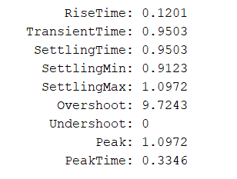

Figure 14: Step of the compensated and Tuned system using PD
Hence the final form for our Transfer function using A Pd controller is:
${G1}_{t}\left(s\right)=$ K * ${Pd}_{new}$* G = ${G1}_{t} (s)$=$\frac{13.39 s +32.94}{s^2 + 0.2235 s}$ i.e. (pd new * k = KP + KD *s)

4.4.PID controller:

By continually correcting mistakes, a PID controller is necessary to achieve reliable, accurate, and quick control of the system. To reduce overshoot, get rid of steady-state mistakes, and guarantee fluid performance in dynamic contexts, it strikes a balance between past, present, and future behavior.
Our main purpose is to Improve the system’s response and to eliminate the steady state, Error (i.e.) , The system is of type 1 hence the ss error = 0 duo FTV but when implementing our system on the hardware the PID proves to be better than the PD.
From previous calculations we were able to determine the angle of deficiency D. Knowing our transfer function G(s) = $\frac{1.602}{s(s+0.2235)}$ we have decided to use the pole zero elimination method, but we made sure that that the zero chosen was 0.2235
and not 0 because the configuration of a PID controller is:
PID = $K*\frac{\left(s+z1\right)*(s+z2)}{s}$ , If the zero chosen is (s), this would lead into designing a PD controller, so we used 0.2235 instead.
Hence the transfer function of the PID controller looks like:
PID = $K*\frac{\left(s+0.2235\right)*(s+z2)}{s}$ now we have 1 equation 1 unknown so we can determine Z2.
Knowing that my compensator should contribute by D, the angle contribution by z2 can be written as such:
- ${ (180-tan}^{-1}(\frac{2 . 183}{1.6-0.2235}))+angle (z2)-(180-\tan^{-1}(\frac{2.183}{1.6}))= 68.47$
By substitution angle (Z2) = 72.475 deg.

Hence z2 = $\frac{2.183}{tan⁡(72.475)}+1.6$ = 2.2897
So the transfer function with the PID controller is: $\frac{s^{2}+2.513 s+ 0.5117}{s}$.
This can be also obtained In MATLAB using:
- tf (conv ([1 z1], [1 -z2]),[1 0]) * G(s)
After finding our Transfer function, we have generated The Step response joined with Stepinfo () and the Root Locus plot for our system.
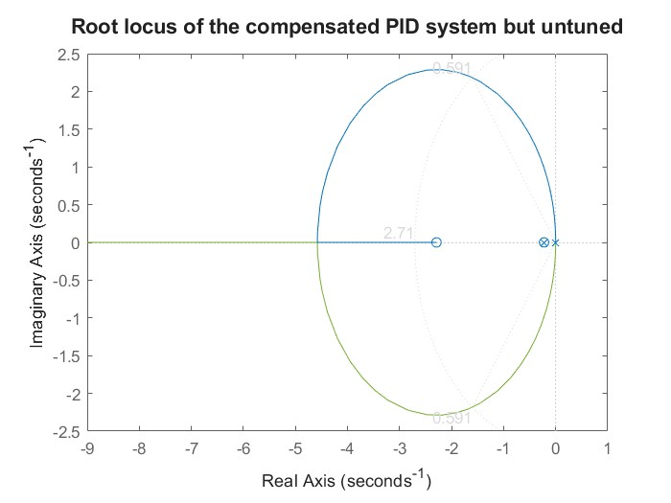

Figure 15: Root locus of the compensated system but untuned using PID

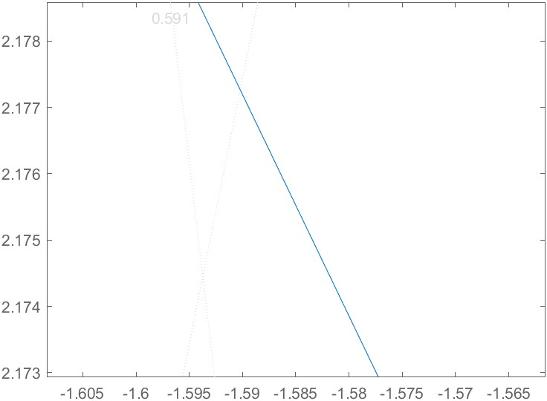
Figure 16: minimized view for the sgrid function

Like the PD configuration the root locus is close to our desired point (i.e.) zeta and Wn desired, but when zooming in we can notice that it is not meeting it at the exact point, hence some fine Tuning is required to either exactly be on the desired point or less than the specified requirements.

4.4.1PID controller, Fine Tuning:
Below there is a Table showing the iterative approach that we took to determine Ki, KD and KP needed to meet the requirements:

Kp | Kd | Ki | Mp (%) | Ts (seconds)
4.993 | 1.987 | 1.016 | 25.3402 | 2.5916
9.986 | 3.974 | 2.032 | 17.0881 | 1.3395
14.979 | 5.961 | 3.048 | 13.1587 | 1.1594
19.972 | 7.948 | 4.064 | 10.7867 | 1.0344
22.4685 | 8.9415 | 4.572 | 9.9131 | 0.9822

With 5 Iterations we were able to reach Satisfactory Results, 9.9131 < = 10 and 0.9822<= 2.5.

The Final form for the transfer function our system looks like the following

${\begin{aligned} \\ Gtuned\end{aligned}}_{PID}(s)$ = $\frac{14.33 s^2 + 36 s + 7.331}{s^3 + 0.2235 s^2}$

We can acquire further information through the plot of the step response and the Stepinfo of our system:

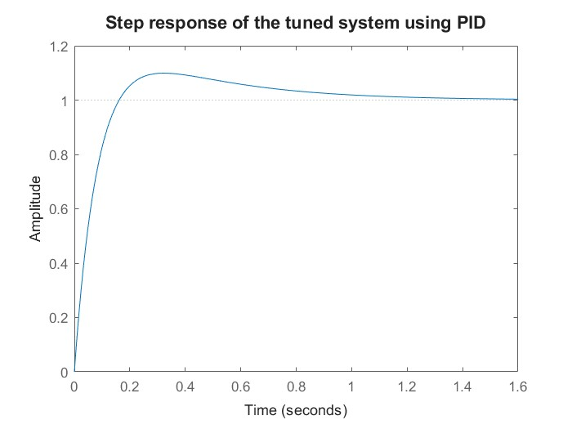
Figure 17:Step of the compensated and tuned system using PID

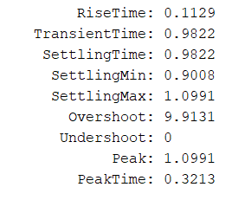

Now that we have determined the Final form of our transfer function and that we have found Kp, Ki and Kd we proceeded by applying our found data on our prototype.

5. Hardware Application:
For the Hardware application we have used Arduino Uno as a controller, the simulation results were close to satisfactory however not exactly.
- Our Pipe has an exact length of 69.9 cm, in our code we have specified the distance measured from the bottom as the output distance hence:
Distance measured from the bottom = (Pipe length – distance measured by the sensor).
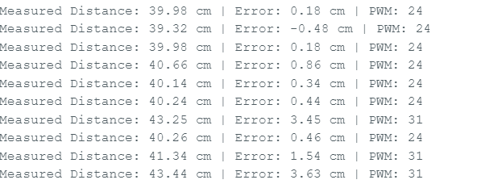

In our case the desired distance was 30 cm , for a steady state error <= 2% the error it should be +/- 0.6 cm or less , In our case satisfactory results can be observed for the first 7—10 seconds but afterwards some instability can be noticed this cycle keeps going on for every time period of 7--10 seconds , this is mainly due to some external factors, in long time ranges our system follows an oscillatory behavior leading to minor instabilities .

6.Appendix:
1. https://www.youtube.com/watch?v=ivpooVlOwys
2. https://tec-control.reutlingen-university.de/remote-experiments/flyball/#tab-8591
3. https://www.politesi.polimi.it/retrieve/a81cb05c-d14e-616b-e053 1605fe0a889a/REPORT.pdf
4. https://www.google.com/url?sa=t&source=web&rct=j&opi=89978449&url=https:// addi.ehu.es/bitstream/handle/10810/59479/TFG_Lucia_Iturbe_Rey.pdf%3Fsequ ence%3D4%26isAllowed%3Dy&ved=2ahUKEwipy6_swaeMAxWdU6QEHbCrBD wQFnoECBUQAQ&usg=AOvVaw1j-O2JTE-2Fx_MdkajUprY
5. https://ieeexplore.ieee.org/document/9071827
6. https://www.sciencedirect.com/science/article/abs/pii/S0019057819302812
7. https://www.google.com/url?sa=t&source=web&rct=j&opi=89978449&url=http://y adda.icm.edu.pl/baztech/element/bwmeta1.element.baztech-3d41e92b-01dc 4571-8b62 f695ced483c2/c/Cholodowicz_LowCost_PAR_4_2017.pdf&ved=2ahUKEwj8pIKx wqeMAxW-K_sDHXNhMUkQFnoECBgQAQ&usg=AOvVaw2br9UVA gy4R3BuBysC5mS
8. https://www.mdpi.com/2227-9717/9/11/1950
9. https://www.youtube.com/watch?v=j1qR7Cu3CrA
10. https://www.youtube.com/watch?v=2WuKIZOhzQ4

